**DBMS LAB 10**

**PROGRAM 10: COLLEGE DATABASE**

Consider the schema for College Database:

STUDENT(USN, SName, Address, Phone, Gender)   
SEMSEC(SSID, Sem, Sec)   
CLASS(USN, SSID)   
SUBJECT(Subcode, Title, Sem, Credits)   
IAMARKS(USN, Subcode, SSID, Test1, Test2, Test3, FinalIA)

Write SQL queries to  
i. List all the student details studying in fourth semester ‘C’ section.

**SELECT S.*, SS.SEM, SS.SEC FROM STUDENT S, SEMSEC SS, CLASS C WHERE S.USN = C.USN AND SS.SSID = C.SSID AND SS.SEM = 4 AND SS.SEC='C';**

1

ii. Compute the total number of male and female students in each semester and in each section.

[**SELECT**](http://localhost/phpmyadmin/url.php?url=https://dev.mysql.com/doc/refman/8.0/en/select.html)**SS.SEM, SS.SEC, S.GENDER,**[**COUNT**](http://localhost/phpmyadmin/url.php?url=https://dev.mysql.com/doc/refman/8.0/en/group-by-functions.html#function_count)**(S.GENDER) AS**[**COUNT**](http://localhost/phpmyadmin/url.php?url=https://dev.mysql.com/doc/refman/8.0/en/group-by-functions.html#function_count)**FROM STUDENT S, SEMSEC SS, CLASS C WHERE S.USN = C.USN**[**AND**](http://localhost/phpmyadmin/url.php?url=https://dev.mysql.com/doc/refman/8.0/en/logical-operators.html#operator_and)**SS.SSID = C.SSID GROUP BY SS.SEM, SS.SEC, S.GENDER ORDER BY SEM;**

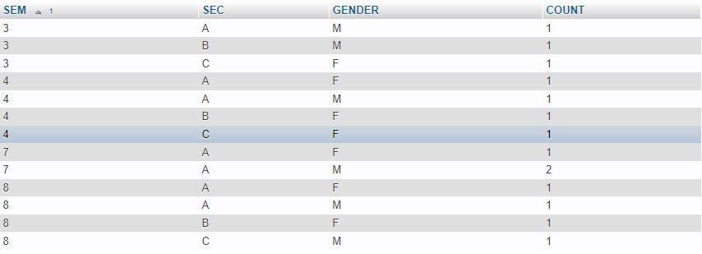

iii. Create a view of Test1 marks of student USN ‘1BI15CS101’ in all subjects.

**CREATE VIEW STUDENT_TEST1_MARKS_V AS SELECT TEST1, SUBCODE FROM IAMARKS**

**WHERE USN = '1BI15CS101';**

**SELECT * FROM STUDENT_TEST1_MARKS_V;**

